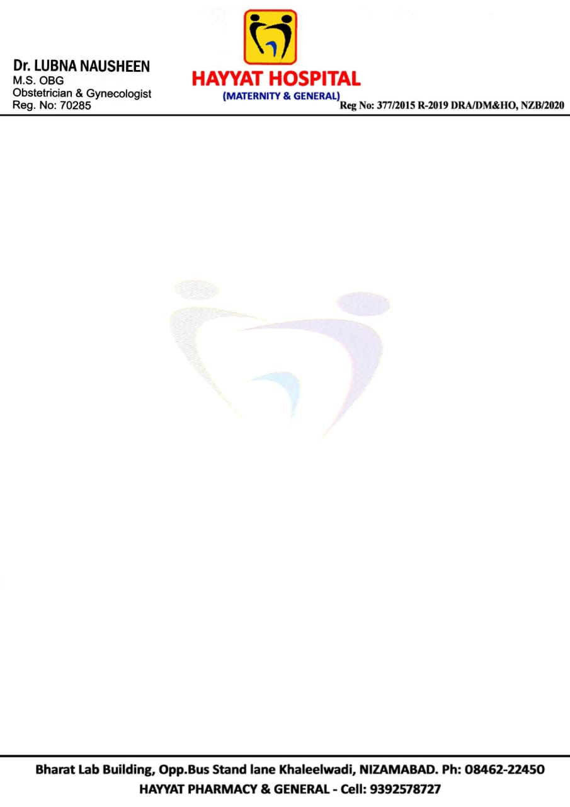

**IP PATIENT TOTAL-FINAL BILL**

|  |  |
| --- | --- |
| **Name : AFIFA SADAF**  **MRNO : HR2001597**  **IPNO : 004987**  **AGE : 22**  **Gender : Female**  **Attendent Name: Mohd Waseemuddin**  **Attendent Mobile: 7013230597**  **Doctor : Dr. LUBNA NAUSHEEN M.S (OBG)** | **Bill Date: 30-11-2022 4:00 pm**  **Bill No: 04881**  **Admitted Date: 27-11-2022**  **Discharge Date: 30-11-2022**  **Floor Name: 2nd Floor**  **Room NO: 209**  **Bed NO: 01**  **Invoice NO: 0124925** |

|  |  |  |  |
| --- | --- | --- | --- |
| **Test/Services** | **Rate (Per Unit/Day)** | **Quantity** | **Amount Total (INR)** |
| **Room Charges** | 1500 | 4 | 6000 |
| **Consultant Doctor Charges** |  |  |  |
| **Operation Theater Charges (C-Section)** | - | - | 5000 |
| **Surgeon Fee (OBSTETRICS AND GYNAC)** | - | - | 22000 |
| **Anesthesia** | 7000 | 1 | 7000 |
| **Nursing Care** | 1000 (per Day) | 4 | 4000 |
| **Blood Transfusion Charges** | 4000 | 1 | 4000 |
| **Oxygen Charges** | - | - | - |
| **Nebulization Charges** | - | - | - |
| **Admission Charges** | - | - | - |
| **Pharmacy** | - | - | 66400 |
| Total | | | 53640 |

**IN WORDS (Rs. FIFTY THREE THOUSAND SIX HUNDRED FORTY ONLY/-)**

**HYATT HOSPITAL**

**BILLING INCHARGE**